

Data Types and OS Memory Management

Samjhana Dahal
Bsc (Hons) Computer Science with Artificial Intelligence
Softwarica College of IT and E-commerce ST5003CMD
Operating Systems, Security, and Networks
Rupak Rajbanshi
29th September 2026

1. Introduction
Data types and memory management are important concepts in computer programming and operating systems. This laboratory demonstrates how C programs use memory through data types, pointers, dynamic memory allocation, and different memory segments of a process. The experiments were performed using C programming language in an Ubuntu Linux environment with the GCC compiler.

2. Objectives
- To determine the memory size of different C data types.
- To understand pointers and dynamic memory allocation.
- To observe the addresses of variables stored in different memory areas.
- To understand the major memory segments of a process.
- To practically observe how C programs interact with memory.

3. Tools and Environment
- Operating System: Ubuntu Linux
- Programming Language: C
- Compiler: GCC
- Terminal: Ubuntu Terminal
- Architecture: 64-bit

4. Experiment 1: Data Type Size

4.1 Create the C Source File
The nano command was used to create and edit the datatype_size.c source file.
Command:
nano datatype_size.c
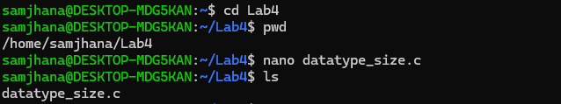
Figure 1: Creating Data Type Program

4.2 Verify the C Source Code
The cat command was used to display the contents of the C source file.
Command:
cat datatype_size.c
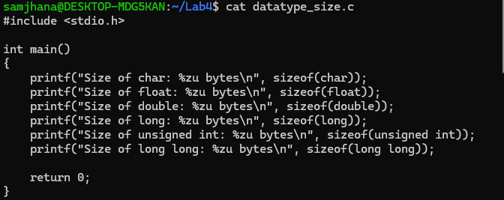
Figure 2 : Displaying the contents of datatype_size.c.

4.3 Compile the Program
The gcc command was used to compile datatype_size.c and create the executable datatype_size.
Command:
gcc datatype_size.c -o datatype_size
Figure 3: Compiling the data type size program.

4.4 Run the Program
The executable was run using ./datatype_size to display the memory size of different C data types.
Command:
./datatype_size
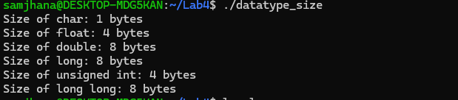
Figure 4: Executing the data type size program and displaying the output.

4.5 View the Generated Files
The ls -l command was used to display the files along with their permissions, ownership, size, and other details.
Command:
ls -l
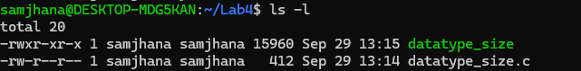
Figure 5: Listing the source file and compiled executable.

5. Experiment 2: Pointer and Dynamic Memory

5.1 Create the Pointer Program
The nano command was used to create and edit the pointer_memory.c source file.
Command:
nano pointer_memory.c
Figure 6: Creating the pointer_memory.c source file.

5.2 Verify the Pointer Program
The ls command was used to verify that the new source file was created in the Lab4 directory.
Command:
ls
Figure 7: Listing the files in the Lab4 directory.

5.3 View the Source Code
The cat command was used to display the complete contents of pointer_memory.c.
Command:
cat pointer_memory.c
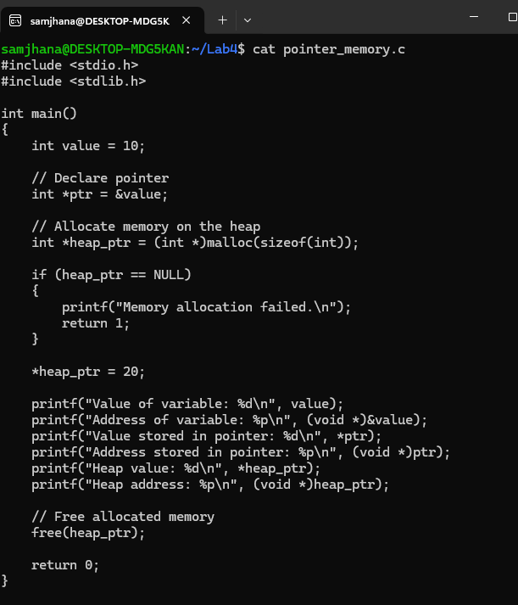
Figure 8: Displaying the contents of pointer_memory.c.

5.4 Compile the Pointer Program
The program was compiled using GCC with warning options to identify possible coding issues.
Command:
gcc -Wall -Wextra pointer_memory.c -o pointer_memory
Figure 9: Compiling the pointer and dynamic memory program.

5.5 Run the Pointer Program
The executable was run to display the variable value, pointer value, and heap memory address.
Command:
./pointer_memory

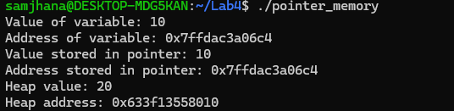
Figure 10: Executing the pointer and dynamic memory program.

6. Experiment 3: Process Memory Segments

6.1 Create the Memory Segment Program
The nano command was used to create and edit the memory_segments.c source file.
Command:
nano memory_segments.c
Figure 11: Creating the memory_segments.c source file.

6.2 View the Source Code
The cat command was used to display the contents of memory_segments.c.
Command:
cat memory_segments.c
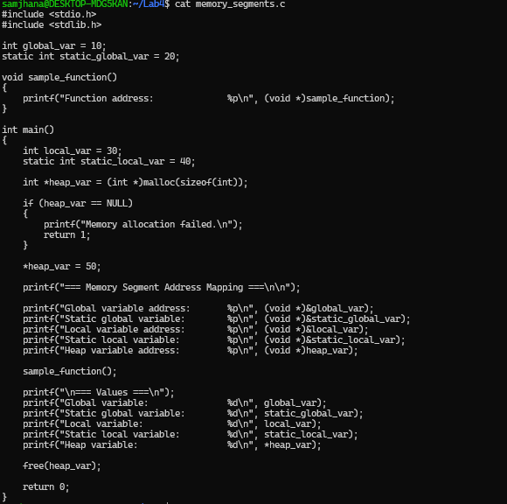
Figure 12:Displaying the contents of memory_segments.c.

6.3 Compile the Program
The gcc compiler was used with -Wall and -Wextra to compile the memory segment program with additional warnings enabled.
Command:
gcc -Wall -Wextra memory_segments.c -o memory_segments
Figure 13:Compiling the memory segment program.

6.4 Run the Memory Segment Program
The executable was run to display the addresses and values of variables located in different memory areas.
Command:
./memory_segments
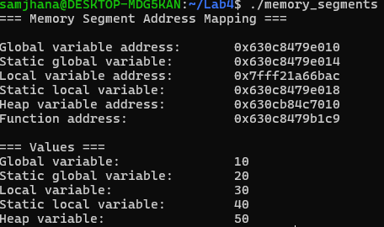
Figure 14: Displaying process memory segment addresses and variable values.

7. Explanation of the Memory Areas
Data Segment:
Stores initialized global and static variables.
BSS Segment:
Stores uninitialized global and static variables.
Heap:
Stores dynamically allocated memory using malloc ().
Stack:
Stores local variables and function-related data.
Text/Code Segment:
Stores executable program instructions, including functions.

8. Conclusion
This laboratory demonstrated data types, pointers, dynamic memory allocation, and process memory segments. The experiments provided practical understanding of how C programs use and manage memory.

GitHub Repository

https://github.com/Samjhanadahal/Systems-and-Networking-.git

